

English Spelling ABC Help file.

This product is design to aid individuals to help, promote their spelling skill set by using the traditional look-cover- write method. The program reads out each word you have entered and therefore you will require Speakers to listen.

**How do you add a new word to the list?**

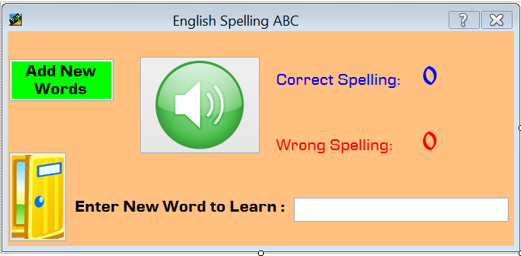

A.)Type the new word you want to learn here

B.)Click on the Add New Words button to add a word to learn

1. Type the new word in the “Enter New Word to Learn “ box
2. Click on the “Add New Words” to save the text

**How do you Exit the program?**

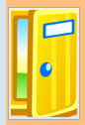To exit the program you will need to click on the Exit button icon

**How can I see what Spelling I have got wrong?**

Each time the spelling test is complete you will be present with a list of wrong spelling and option to print these wrong spelling. Upon exit you will lose all your wrong spelling list , its recommended that you print these out as you will need to practise the spelling you have got wrong.

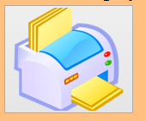

Click on the Print Icon to print.

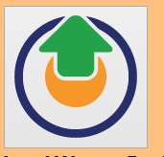

Click on the “Load Wrong Spelling” icon to see which spelling you have got wrong.



To exit this screen you will need to click on the exit icon

If you would like to suggest or need further help with anything please don’t hesitate to contact me on [dynexenquiry@outlook.com](mailto:dynexenquiry@outlook.com) , we shall endeavour to reply back within 48 hours.